
Discovering Knowledge

COURSE: CSC 221
DATA STRUCTURE AND ALGORITHM
PROJECT REPORT
CLASS: BSE – 3B (FALL - 2025)

STANS

Group Members

Student Name | Enrollment
Muhammad Waleed Ahmed (Team Leader) | 02-131242-119

Submitted to:
Course Instructor: Engr. Majid
Lab Instructor: Engr. Sania

Contents
1. INTRODUCTION & PROBLEM 3
2. PARADIGMS 3
3. ALGORITHM & EXPLANATION 4
4. ALGORITHM CODE
5. INTERFACES 4
6. CONCLUSION 9

INTRODUCTION & PROBLEM
STANS (Smart Traffic-Aware Navigation System) is designed to demonstrate practical implementation of Data Structures and Algorithms using real-world scenarios. Traditional navigation systems often ignore dynamic factors such as traffic congestion and road blockades. STANS addresses this problem by modeling roads as a traffic-aware weighted graph and applying multiple graph algorithms to compute efficient routes with live data and visualization.

PARADIGMS
- Agile Development Model: The project was developed iteratively, allowing continuous feature addition such as API integration, live traffic control, and algorithm comparison.
- Frontend Stack: React 18 with TypeScript for type safety and component-based architecture.
- Tooling & Styling:
Vite for fast builds
Tailwind CSS for responsive UI design.
- Visualization
LibrariesThree.js (3D Visualization)
Framer Motion (Animations)
Recharts (Data Visualization)

ALGORITHM & EXPLANATION
STANS implements and visualizes multiple graph algorithms:
- Kruskal’s Algorithm:
Builds a Minimum Spanning Tree (MST) using edge-based greedy selection with Union-Find (DSU).
- Prim’s Algorithm:
Generates MST by expanding from a starting node.
- Dijkstra’s Algorithm:
Finds the shortest path between specific source and destination nodes.
- Union-Find Data Structure: Union-Find (DSU) is used to efficiently track connected components and detect cycles in Kruskal's algorithm.
- Graph Data Structure
The graph is represented using an edge list with traffic-aware weights, suitable for sparse road network

ALGORITHM CODE
GitHub link : https://github.com/weedu230/STANS

INTERFACES
LANDING PAGE
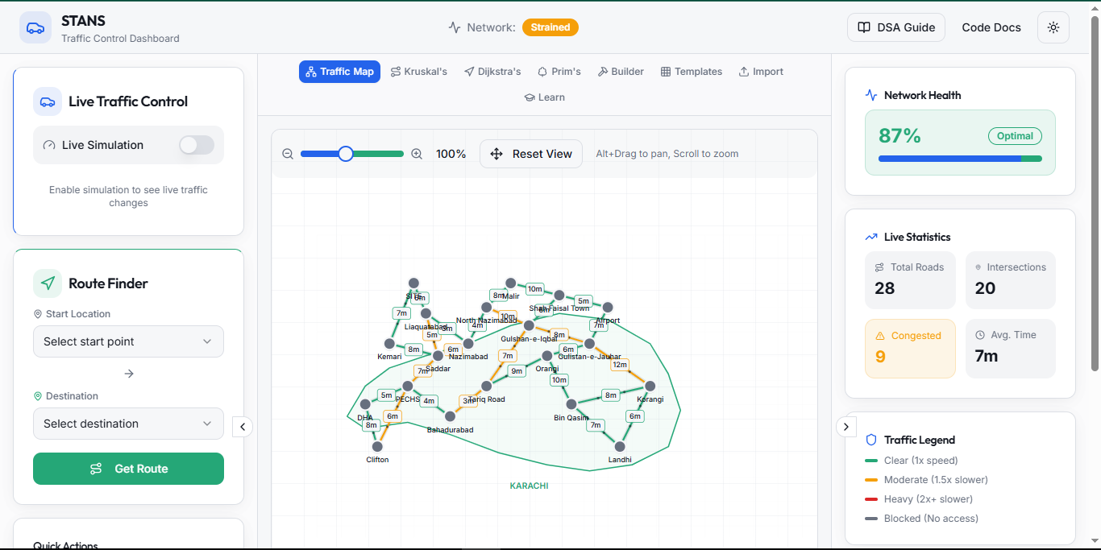
KRUSKAL
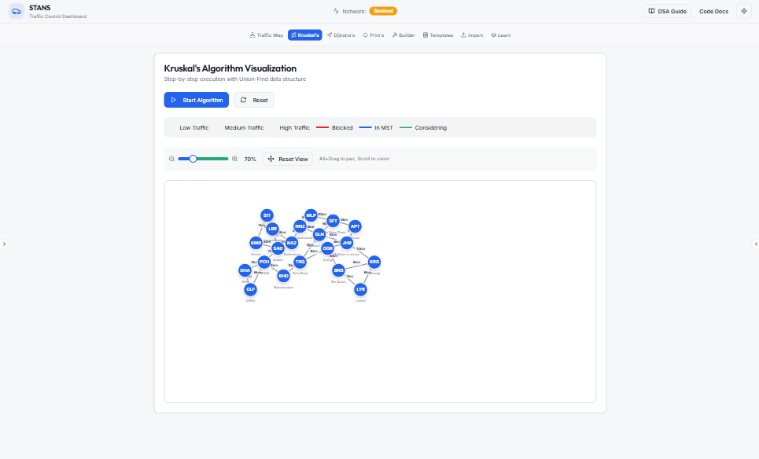
dijksTRAS
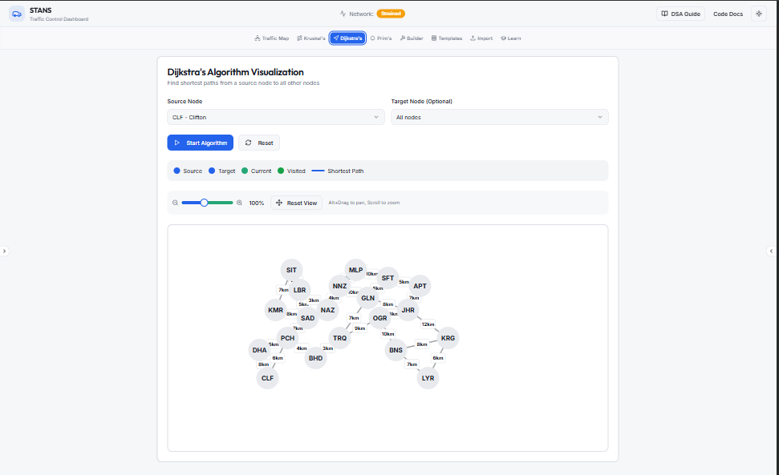
prims
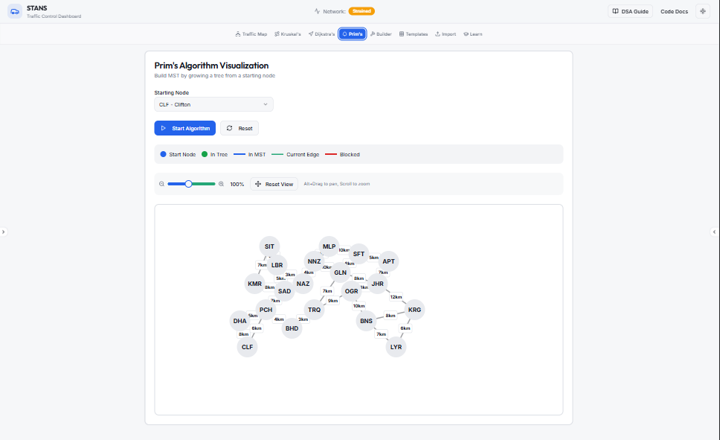
graph builder
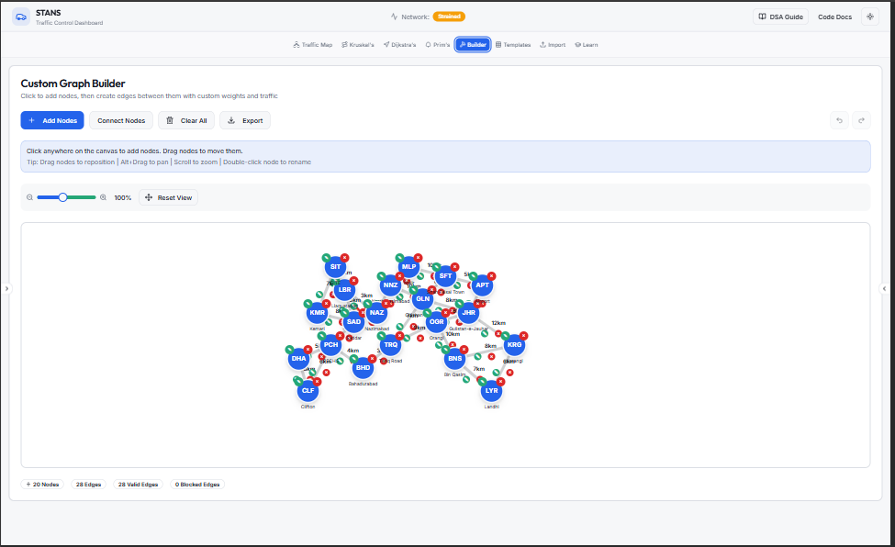
templates (maps + GRAPH)
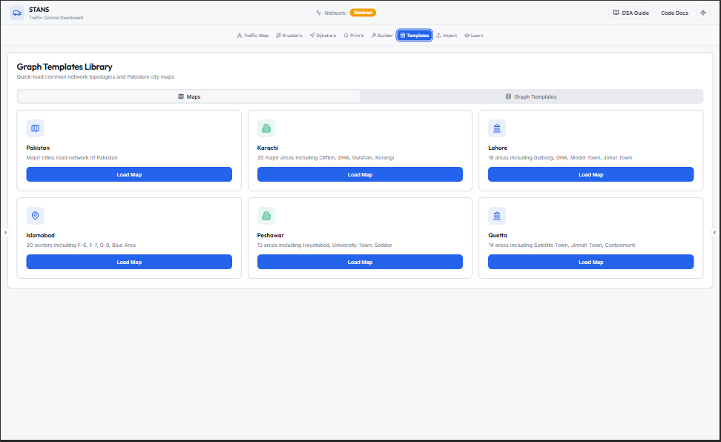

import/export
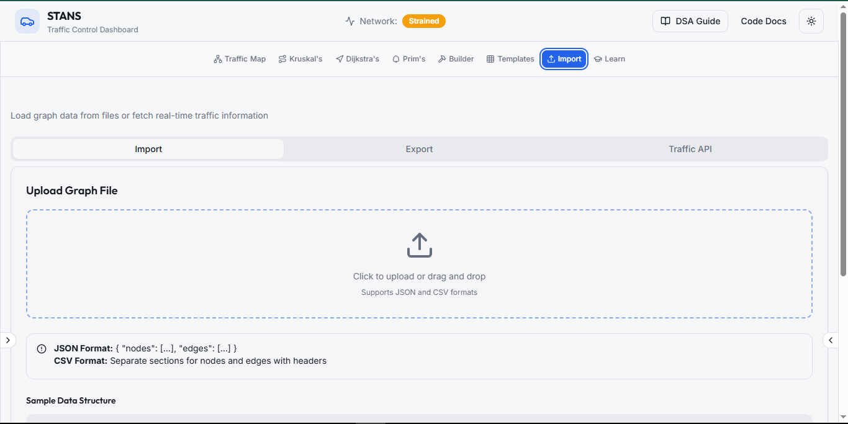
api integerator
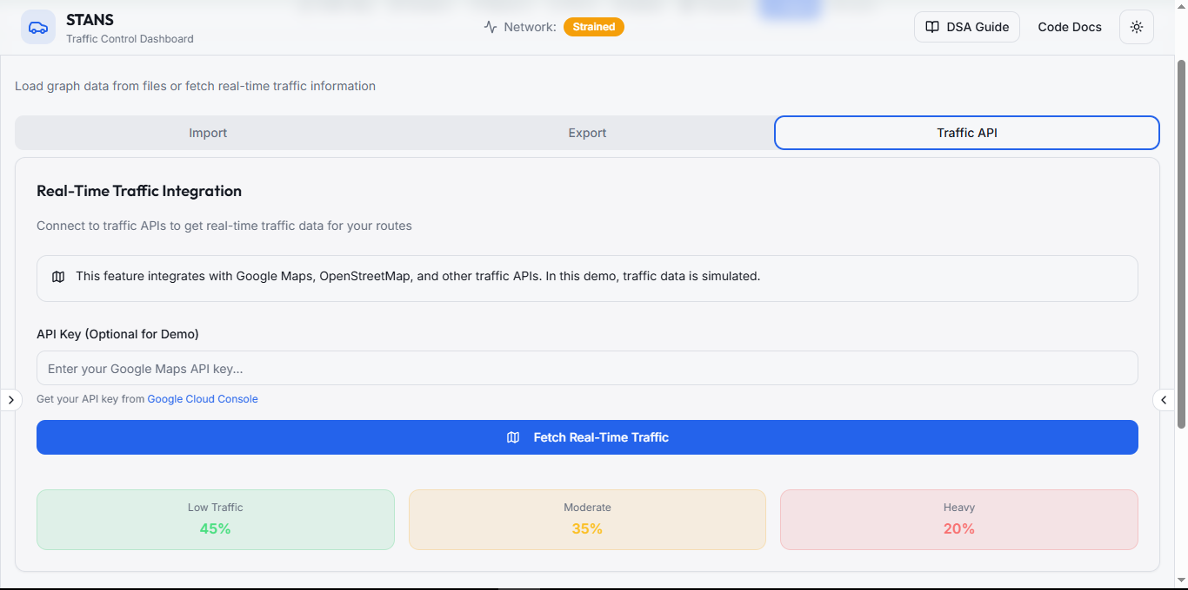

code explained
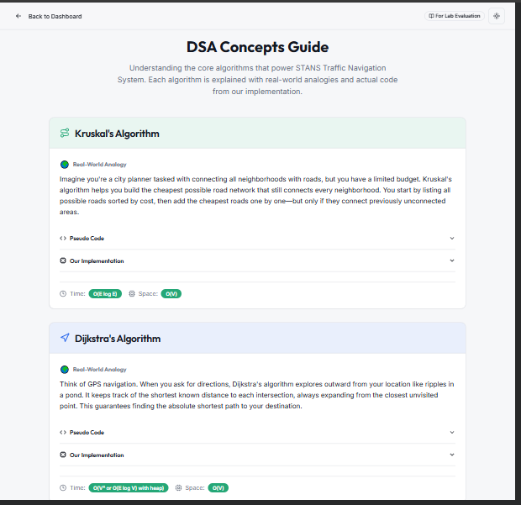

6. CONCLUSION
STANS is a feature-rich DSA project that combines graphs, greedy algorithms, shortest-path algorithms, and real-time data handling. By integrating API-driven traffic, multiple algorithms, and interactive visualization, the project clearly demonstrates strong practical understanding of Data Structures and Algorithms beyond theoretical implementation.

